• Python tutorial

• Android tutorial

• http://www.W3Cschool.com

• Reference books:

• Learning Python, Django, Mysql and Javascript by Robin Nixon

• Python Solutions:Dynamic Web Design Made Easy by Dav

# NMKRV College for Women



**Project Report on**

**“Elearn (Elearning website)”**

**Submitted in partial fulfillment of the Requirements of the 6th Semester in**

# **BACHELORS OF COMPUTER APPLICATIONS**

**By**

# **NAME:Siva Ranjini H**

# **USN:U03PE22S0011**

## Under the Guidance of

## Mrs.Haritha

## Asst. Professor

Dept. of Computer Applications

NMKRV College for Women



**NMKRV College For Women**

**45/1,22nd Cross, Jayanagar, III Block  
Bengaluru-560011**

**BONAFIDE CERTIFICATE**

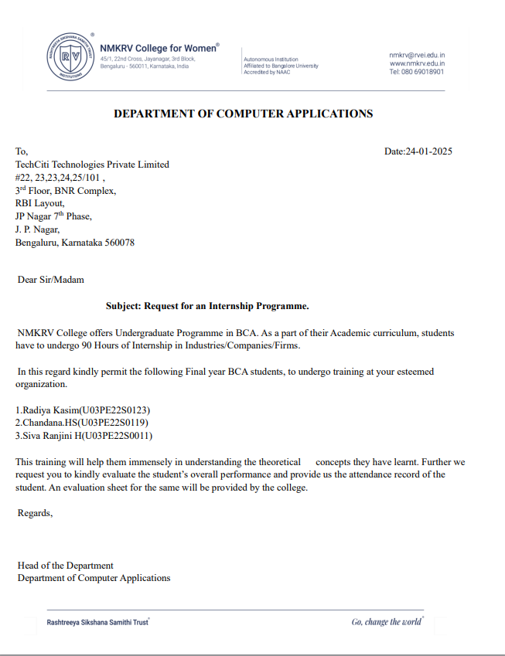

**ACKNOWELDGEMENT**

I would like to place on record my gratitude to all those people who have helped me in making this Project work a reality. Our Institution has played a prominent role in guiding in the right direction.

I would like to thank our beloved Principal, **“** DrSnehalatha Nadiger **”**, for providing the necessary facilities to carry out this work.

I am extremely grateful to**”Prof. Deepa Lakshmi ”,** Professor and Head, Department of BCA for having accepted to patronize me in the right direction with all his wisdom.

I would like to express my sincere thanks to our project guide, **“Prof. Haritha“**, Assistant Professor, for his constant encouragement that motivated me for the successful completion of this work.

I am thankful to all the teaching and non-teaching staff members of the BCA Department for their encouragement and support throughout this work.

**Siva Ranjini H**

**( U03PE22S0011)**

**Table** **of** **Contents**

|  |  |
| --- | --- |
| BONAFIDE CERTIFICATE |  |
| ACKNOWELDGEMENT |  |
| TABLES OF CONTENT |  |
| INTERNSHIP CERTIFICATE |  |
| ATTENDENCE SHEET |  |
| WEEKLY OVERVIEW OF INTERNSHIP ACTIVITIES |  |
| ABSTRACT |  |

|  |  |  |  |
| --- | --- | --- | --- |
| Chapter 1. Introduction | | |  |
|  | 1.1 Company profile | |  |
|  | 1.2 Project/Internship Objective | |  |
|  | 1.3 Tools used | |  |
|  |  | 1.3.1 Hardware specification |  |
|  |  | 1.3.2 Software/Libraries/Modules used |  |

|  |  |  |
| --- | --- | --- |
| Chapter 2. LITERATURE SURVEY | |  |
|  | 2.1 eLearning champions to help encourage departmental innovations in eLearning. |  |
|  | 2.2 Analysing and contrasting several machine learning models for online learning dilatory behaviour prediction. |  |
|  | 2.3 JUX is an OpenedX-based educational management system that runs on the cloud. |  |
|  | 2.4 Equitable Access to eLearning during Covid-19 Pandemic and beyond. A Comparative Analysis between Rural and Urban Schools in Zimbabwe |  |
|  | 2.5 The Role of Online Education in Sustaining Higher Learning After COVID-19 |  |
|  | 2.6 EXISTING SYSTEM |  |
|  | 2.7 PROPOSED SYSTEM |  |
|  | 2.8 FEASIBILITY STUDY |  |
|  | 2.9 Economic Feasibility |  |
|  | 2.10 Technical Feasibility |  |
|  | 2.11 Social Feasibility |  |

|  |  |  |  |  |
| --- | --- | --- | --- | --- |
| Chapter 3. Django Project Creation | | | |  |
|  | 3.1 Django | | |  |
|  | 3.2 Bootstrap | | |  |
|  | 3.3 LIBRARIES | | |  |
|  |  | | 3.3.1 NumPy |  |
|  |  | | 3.3.2 Pandas |  |
|  |  | | 3.3.3 Scikit learn |  |
|  |  | | 3.3.4 |  |
|  |  | | 3.3.5 |  |
|  | 3.4 HTML : | | |  |
|  | 3.5 CSS : | | |  |
|  | 3.6 JavaScript : | | |  |
|  | 3.7 MySql | | |  |
|  | 3.8 DJANGO INSTALLATION | | |  |
|  |  | 3.8.1 Install recent version of Python | |  |
|  |  | 3.8.2 PIP (Preferred Installer Program) | |  |
|  |  | 3.8.3 How To a Create Virtual Environment for Python | |  |
|  |  | 3.8.4 Installing Django in The Virtual Environment | |  |
|  |  | 3.8.5 Creating A Django App | |  |

|  |  |  |  |
| --- | --- | --- | --- |
| Chapter 4. METHODOLOGIES | | |  |
|  | 4.1 Admin Modules | |  |
|  | 4.2 Dashboard: | |  |
|  |  | 4.2.1 User (Student) Modules |  |
|  |  | 4.2.2 User (Instructor) Modules |  |
|  | 4.3 Database Tables | |  |
|  |  | 4.3.1 Contact Us: |  |
|  |  | 4.3.2 Contact Data View: |  |
|  |  | 4.3.3 New Table Creation: |  |
|  | 4.4 SYSTEM DESIGN | |  |
|  | 4.5 TESTING METHODS | |  |
|  |  | 4.5.1 UNIT TESTING |  |
|  |  | 4.5.2 INTEGRATION TESTING |  |
|  |  | 4.5.3 ACCEPTANCE TESTING |  |
|  |  | 4.5.4 Functional test |  |
|  |  | 4.5.5 System Test |  |
|  |  | 4.5.6 White Box Testing |  |
|  |  | 4.5.7 Black Box Testing |  |

|  |  |  |  |
| --- | --- | --- | --- |
| Chapter 5. RESULTS / OUTPUTS | | |  |
|  | 5.1 OUTPUTS | |  |
|  |  | 5.1.1 Elearn.html(Home) |  |
|  |  | 5.1.2 Course.html(DB connected) |  |
|  |  | 5.1.3 Sign up.html/login.html |  |
|  |  | 5.1.4 About.html |  |
|  |  | 5.1.5 Contact.html(DB Connected) |  |

|  |  |
| --- | --- |
| Conclusion |  |
| Reference |  |
| User Manual |  |

**INTERNSHIP CERTIFICATE**

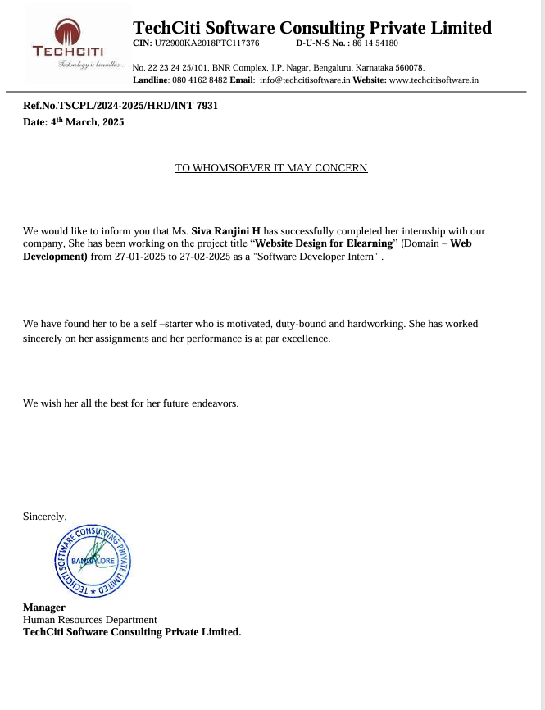

**Signature** **of** **Student**

**Siva Ranjini H**

**ATTENDENCE SHEET**

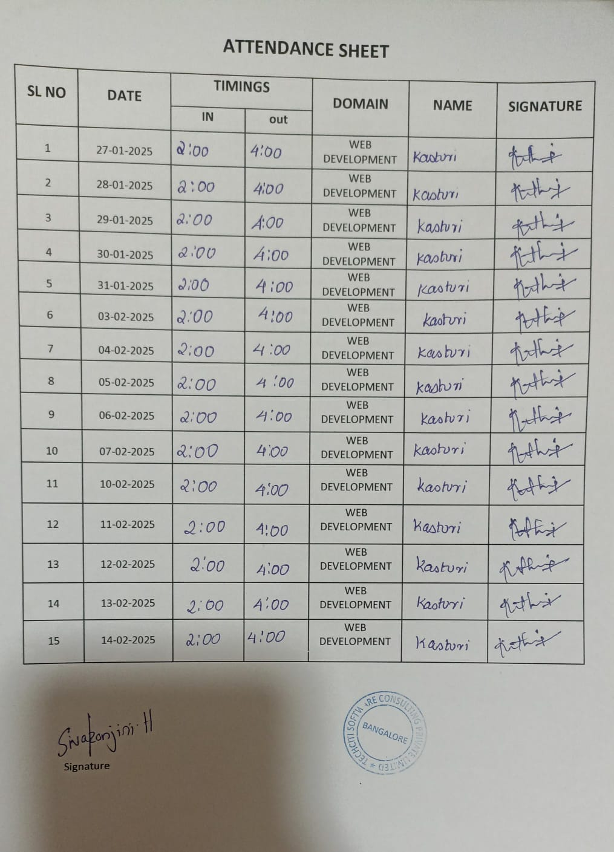

**WEEKLY OVERVIEW OF INTERNSHIP ACTIVITIES**

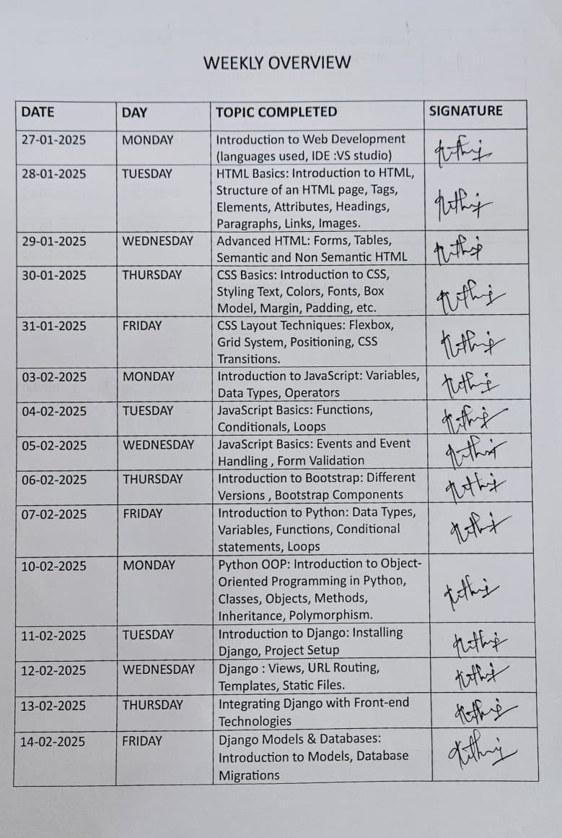

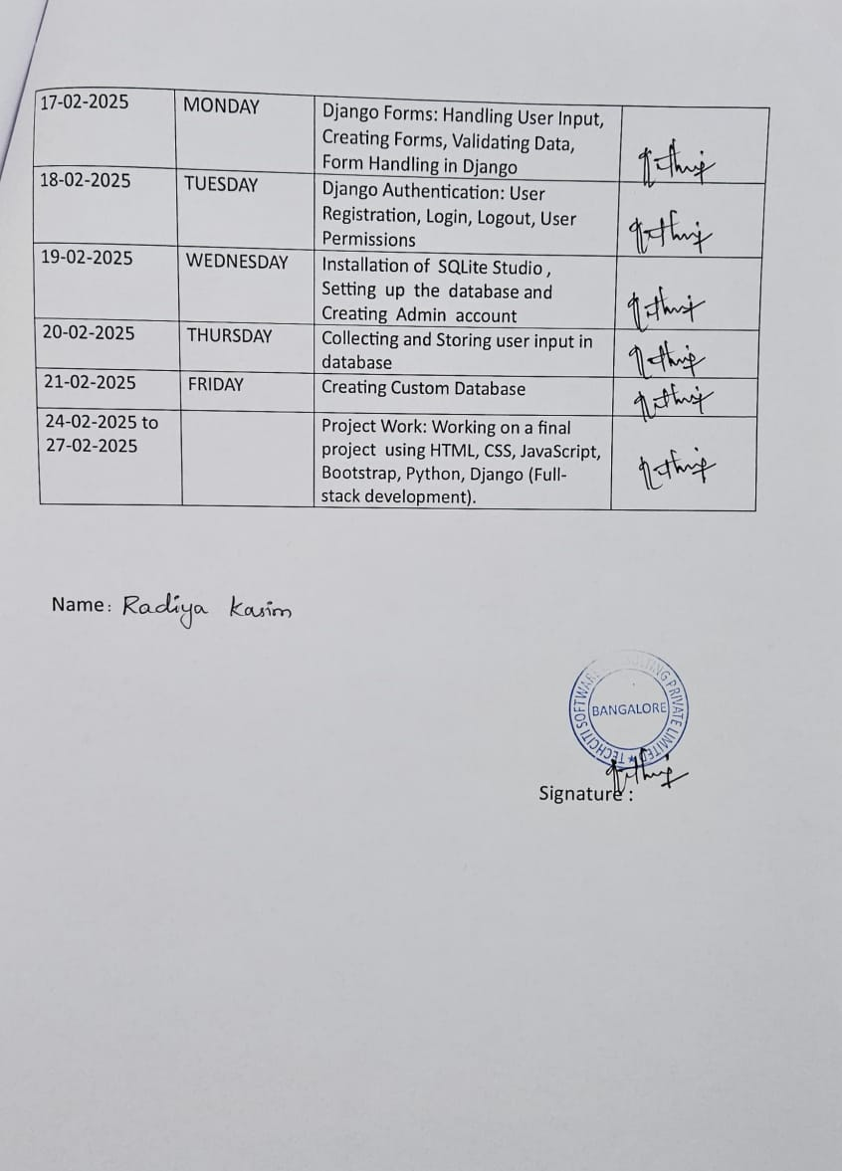

**ABSTRACT**

One fundamental difficulty with traditional learning environments is that neither students nor instructors are able to properly get ready for the learning process. Additionally, there is no way to reproduce previously delivered educational content, and the limited quantity of knowledge that can be conveyed through teachers' brief notes and explanations is also a constraint. This method is not only wasteful, but it also limits your learning opportunities by making information unavailable at inconvenient times or locations. Digital material, generally referred to as technology for communication and information (ICT), is more popular and relied upon by today's students. The condition is advantageous for online or virtual activities since it enables the storing, sharing, and access to educational resources over the World Wide Web. This R&D project's overarching objective is to build an LMS-based e-learning platform with the intention of piloting it in the Mechanics Mechanical Engineering class's Micro instruction. Needs analysis, creation, creation, and execution are the four stages that make up the Hannafin and Peck method model, which forms the basis of the research technique. After that, experts in the field of media and materials verify the created learning management system based on their expertise. Fifteen adult undergraduates (ranging in age from 22 to 25) were enlisted for this investigation. The data collection approach makes use of both questionnaires and first-hand observation. It is "very feasible" to implement the conclusions based on the research conducted on LMS-based e-learning development. Education management system (LMS) usability, LMS features, visual interaction, academic design, content, language and conversational usage, and the content itself are the assessment criteria. According to the results of this study, using a learning management system improves both student happiness and the level of their education.

**CHAPTER 1. INTRODUCTION**

Economic factors almost certainly will lead to a large-scale spread of e-learning systems; but, the demand from students for more adaptability and a focus on their needs will drive this growth to an exponential level. As a versatile and innovative way to access possibilities, e-learning is thought of as supporting and enabling successful teaching and learning. Electronic learning, or e-learning, is defined as "the systematic use of connected, multimedia equipment with the aim of enhancing learning," "empowering learners," "integrating learning with performance," "linking individuals with organisational goals," and "connecting pupils with individuals and assets that are supportive of their needs"

[1]. Actually, distant education is an option for those who, for various reasons, are unable to keep up with their regular course attendance and so cannot continue their education in the traditional sense. Many of the problems with distant learning may be solved by using e-learning. These include the lack of regular contact between a student and teacher, the inability to review previously covered material, and many more. With the advent of e-learning, traditional classroom instruction and corporate training have both undergone radical shifts. With the help of e-learning, we can all have access to high-quality education, which might completely change the way we learn and help every student reach his or her maximum potential

[2]. The training and education that is now being offered at universities and other cooperative education programmes has a lot of problems. Prior to enrolling in online classes, students should be cognizant of a number of concerns associated with online education. It can be challenging to convey the importance of reading meticulously, paying attention, avoiding distractions, and practicing discipline with students. Issues such as lecturers' lack of preparation and dedication, faulty modern technology that makes it hard to keep tabs on students, and instructors' significant workloads or lack of experience with new technologies rendering them unresponsive are also factors.   
Because of these problems, researchers are conducting this study in the hopes of creating a digital learning platform that schools and other organisations like universities may use. It not only lets teachers share course materials online, but it also lets students engage in one-on-one conversations with them by giving them a way to ask questions and obtain answers without ever leaving the classroom. The system is not only reliable and easy to use, but it can also be upgraded to meet more modern standards. The e-learning platform was developed using PHP, Django, Bootstrap, MySQL, and HTML/CSS.

### **1.1 Company profile**

Established as a Private Limited Company in the year 2013, we “Techciti Technologies Private Limited” are a leading Wholesaler Trader and Service Provider of wide range of quality products and services like Apple Macbook, Dell Laptop etc.  
  
Provide customized solutions for businesses of all sizes with a wide range of services. Our free consultation service helps you determine your requirements and we assist with product selection, configuration, and installation. Our focus is on demonstrating our value by helping you choose the right technology, bringing competitive pricing to the table, remaining predictable in our execution, and providing excellent post-sales support. Established in 2013, TechCiti has become a pioneer in end-to-end IT infrastructure solutions, with business functions in 12+ major Indian cities and satisfied corporate customers.

### **1.2 Project/Internship Objective**

The project's principal objective is to provide students with an online resource for learning core courses. The following features will be present in the project:

1.It is recommended to combine "interactive" theory lectures with "hands-on" labs.   
2. A wealth of information is at your fingertips.   
3. Receiving assignments is a distinct possibility.

4. Experienced teachers with the necessary skills, Software that facilitates the administration, monitoring, and delivery of educational and training programmes is known as an educational portal. Software that facilitates online course distribution and provides features for online collaboration is one kind of learning management system; another is a system for keeping track of training and education data. Online tutors are a common tool for corporate training departments looking to automate record-keeping and employee course enrollment. Because of this, both operations may be automated.

### **1.3 Tools and technologies used**

**Description of Technology Used:**

**Python**

**1. Simple and Readable Syntax:**

• Clean, easy-to-read syntax with indentation for code blocks.

**2.** **High-Level Language:**

• Abstracts complex details, uses dynamic typing.

**3**. **Interpreted Language:**

• Executes line-by-line, cross-platform compatibility.

**4.** **Extensive Standard Library:**

• Rich set of built-in modules and functions.

**5.** **Object-Oriented Programming:**

• Supports classes, objects, and OOP principles.

**6.** **Dynamic and Duck Typing:**

• Types are determined at runtime; focuses on behavior rather than type.

**7.** **Vast Ecosystem:**

• Numerous third-party libraries and frameworks (e.g., Django, Pandas).

**8.** **Integration Capabilities:**

• Interfaces with other languages and systems.

**9.** **Active Community:**

• Large, supportive community and extensive documentation.

**10. Beginner-Friendly:**

• Easy to learn and use, with an interactive shell for experimentation.

**11. Cross-Platform Compatibility:**

• Runs on any platform with a Python interpreter, supports virtual environments.

**12. Modern Programming Paradigms:**

• Supports functional programming and concurrency.

**13. Data Science and Machine Learning:**

• Strong libraries for data analysis and machine learning (e.g., NumPy, TensorFlow).

**14. Testing and Debugging:**

• Built-in and third-party tools for testing and debugging.

### **1.3.1 Hardware specifications**

* Processor: Pentium-III (or) Higher
* Ram: 64MB (or) Higher
* Hard disk: 80GB (or) Higher

### 1.3.2 **Software specifications**

* Technology: Python Django
* IDE : Pycharm/Atom
* Client Side Technologies: HTML, CSS, JavaScript , Bootstrap
* Server Side Technologies: Python
* Data Base Server: Sqlite
* Operating System: Microsoft Windows/Linux

**Chapter 2**

**LITERATURE SURVEY**

2.1 **eLearning champions to help encourage departmental innovations in eLearning.**

AUTHOR: [Sweta Patnaik](https://ieeexplore.ieee.org/author/37088588907); [Daniela Gachago](https://ieeexplore.ieee.org/author/37088590234)

Year:2020

While online and blended learning were becoming increasingly popular throughout the world, not all implementations were able to revolutionise the way students learned. Supplementing more traditional forms of teaching and instruction with technological tools is a popular practice. Our institution's preferred blended learning model places more focus on pedagogical concerns than on the technology and resources utilised in the classroom. Following Gilly Salmon's Carpe Diem design philosophy, we propose that professors pay close attention to learning design, highlighting the needs of students in relation to the field and the institution's overall setting. This study aims to investigate the lived experiences of six faculty members from the Engineering and Construction Environment Faculty who are sometimes called "eLearning champions." An eLearning champion is "someone who comes forward to take novel ideas (that they may or may not have created) and make them a reality." By enthusiastically championing the invention, rallying support for it, removing obstacles to it, and seeing it through to implementation, they significantly contribute to the innovation process [1]. Our focus lies in delving into the ways in which these eLearning advocates supported their departments during and after COVID-19 in making the shift to online education. New professors saw online education at its inception as merely a continuation of their traditional classroom methods implemented in a digital setting. Designing for student engagement, appropriate online assessment, and interactive online content was unfamiliar territory. While the research is still in its early phases, several themes have emerged, including the role of e-learning champions and their participation in peer learning. It goes on to mention the institution's help and the complexity of the situation, among other things. The essay will conclude with some suggestions for further research.

2.1.1 **Analysing and contrasting several machine learning models for online learning dilatory behaviour prediction.**

AUTHOR: [Christof Imhof](https://ieeexplore.ieee.org/author/37089867500); [Ioan-Sorin Comsa](https://ieeexplore.ieee.org/author/38548099800); [Martin Hlosta](https://ieeexplore.ieee.org/author/37086726744)

Year:2022

When it comes to online learning, procrastination, which is defined as the illogical postponement of work, is a typical occurrence. Some of the potential adverse effects include an increased likelihood of dropping out of school, a rise in stress, and a decrease in mood. The proliferation of learning management systems (LMS) as well as educational analytics (LA) has made it possible to identify signs of such behaviour, which in turn enables predictions of future procrastinating and other forms of dilatory behaviour with greater accuracy. On the other hand, there is a dearth of research that focuses on such forecasts. In addition, there are almost no research that involve several kinds of predictors, and there are almost no comparisons made between the predictive ability of different approaches for predicting outcomes. In this article, we intend to fill these research gaps by analysing the performance of different algorithms for machine learning when predicting the delayed or timely delivery of online assignments in a higher education setting. We will use two categories of indicators: 1) subjective, questionnaire-based variables, and 2) objective, log-data-based indicators extracted from a system for managing learning. Both of these categories of predictors are described below. The findings indicate that models with objective predictors consistently perform better than models with subjective predictors. Furthermore, a mixture of both types of variables works somewhat better, with an accuracy of 70%. Different strategies were used for each of these three possibilities: gradient boosting machines were used for the subjective, Bayes multilevel mathematical models were used for the objective, and Random Forest was used for the combined predictors. The conclusion that we have reached is that prior to adopting such models in learning management systems, great consideration ought to be given to the selection of predictors relevant algorithms via careful attention.

2.1.2 **JUX is an OpenedX-based educational management system that runs on the cloud.**

Author: [Muhammad Noman Saeed](https://ieeexplore.ieee.org/author/37089109765); [Ahmad Mufarreh Al Mufarreh](https://ieeexplore.ieee.org/author/37089684630)

Year:2022

As a result of the global spread of the COVID-19 pandemic, universities and colleges throughout the world have begun to promote online education as an alternative to traditional classroom instruction. In order to provide a strong learning environment that can handle the difficulties encountered by teachers, students, and system administrators due to the quick pace of development, the provider of online education has to be knowledgeable in the field. Increasing the network's connection, bandwidth, and other features is necessary for the system administrator to ensure that online courses can run smoothly with the college's other network services. Other campus network facilities may encounter difficulties while attempting to supply seamless services for e-learning. Consequently, the university administration and management suggest putting the online learning services on the cloud and keeping them outside from the campus network. In the event that the institute is encountering bandwidth issues or limited hardware resources, this will alleviate the problem of limited network resources. Furthermore, the use of cloud computing helps to reduce the original investment as well as the continuing expenditures of running the services. This project will seek to overcome the above identified challenge in order to provide OpenedX-based educational products with an affordable cloud architecture based on the services of Amazon Web Service (AWS). Presenting a technological solution for the method of developing a cloud-hosted learning management system is the objective of this research.

2.1.3 **Equitable Access to eLearning during Covid-19 Pandemic and beyond. A Comparative Analysis between Rural and Urban Schools in Zimbabwe**

Author: [Gerald Tsimba](https://ieeexplore.ieee.org/author/37088479494); [Beauty Mugoniwa](https://ieeexplore.ieee.org/author/37088488256); [Amanda Nyasha Mutembedza](https://ieeexplore.ieee.org/author/37088488428)

Year:2022

Their motivation for taking part in this study was the widening gap in access to technology between pupils in Zimbabwe's urban and rural communities. Because schools in rural areas were forced to adopt eLearning systems due to the COVID-19 pandemic breakout in 2020, rural children were disenfranchised and the situation became even worse. During the COVID-19 pandemic, the study aimed to compare rural and urban schools in terms of equitable access to eLearning and to see if rural schools had the necessary resources to implement eLearning. The study made an effort to employ a mixed-methods approach based on a pragmatic philosophical position in relation to this issue. The results showed that out of the 112 participants in the research, all hailing from schools in Zimbabwe's Goromonzi area, an exploratory case study methodology yielded the best quantitative and qualitative data. A survey was used to get quantitative data in 2020 and an ethnographic method was used to gather qualitative data in 2021. According to the study's results, rural schools suffered greatly as a result of the COVID-19 pandemic's use of online education. The reason behind this is that online schools were only accessible to a small number of pupils. The widening gap in educational opportunities between urban and rural pupils was mostly caused by inadequate infrastructure and resources for computer technology (ICT). Consequently, the study proposed an eLearning adoption approach, which important players in the educational school system may use in emergency situations.

2.1.4 **The Role of Online Education in Sustaining Higher Learning After COVID-19**

Author: [Hajar Mahfoodh](https://ieeexplore.ieee.org/author/37088633423); [Hessa AlAtawi](https://ieeexplore.ieee.org/author/37088823872)

Year:2020

For quite some time, universities and colleges throughout the globe have vocally opposed the introduction of online courses, insisting instead on the traditional classroom setting. However, because to the COVID-19 blackout, online learning has replaced traditional classrooms as the only viable alternative. Higher education institutions' embrace of eLearning as a solution has presented long-standing notions of pedagogy and academic bodies with a much-anticipated challenge. When it comes to curriculum delivery, most schools have been able to hold their own with the introduction of eLearning labs and apps. This is how eLearning has shown to be a potent tool for keeping universities open in the face of natural disasters and other catastrophic events. However, there is no practical way to keep education as a means of efficient instruction going forward. In light of this, this article's goal is to look at what COVID-19 could mean for the future of education throughout the world. This research concludes that online education, or eLearning, is the best alternative for institutions that want to keep their students enrolled in higher education by implementing an internet-based curriculum. Previous research and studies have examined eLearning as a necessity in the education sector, and this study builds on that foundation. It is descriptive and analytical in nature. An examination of the pros and cons of eLearning in higher education institutions is carried out using the SWOT model as part of the literature review. The SWOT analysis might help you avoid making the same mistakes when you launch an eLearning course in the post-COVID-19 world. We may do this by taking stock of the opportunities, threats, weaknesses, and overall situation. The study concludes that eLearning will be indispensable in the post-COVID-19 era because to its proven effectiveness and longevity, as well as the fact that its risks and shortcomings have been addressed and resolved. The article's study and findings formed the basis for this conclusion.

2.2 **EXISTING SYSTEM**

The training and education that is now offered through colleges and other cooperative education programmes has a lot of problems. Not only that, but students may find that their professors aren't as approachable as they'd like due to their own workloads or lack of familiarity with the new technology. On top of all that, students who struggle to read, follow directions, reduce distractions, and use self-discipline may find it difficult to interact with peers who aren't prepared to handle the various online learning environments.

2.3 **PROPOSED SYSTEM**

The supplied requirements statements specify the skills and outcomes that the system for e-learning will give. In addition to directing the development of specific system deliverables, requirements also help in evaluating whether or not such deliverables are sufficient for their intended use. System requirements describe what is needed, system deliverables describe how it is done, and system outcomes describe why buying the system is a good idea. Courses, levels, users, departments/units, students, and instructors may all be managed by the administrator

2.4 **Feasibility study**

This part of the process involves figuring out whether the idea is feasible and then presenting a business proposal with a very general business plan and some estimates of costs. A feasibility study of the proposed system must be carried out in the course of the system analysis. This will ensure that the proposed solution will not put undue strain on the company. You need to know the system's essential requirements inside and out before you can do a feasibility study. The following three elements are considered crucial in the feasibility analysis:

1. Economical Feasibility
2. Technical Feasibility
3. Social Feasibility

2.5 **Economic Feasibility**

Examining the system's prospective benefits and drawbacks in relation to the organization's financial situation is the driving force behind this research. Developing the system through research and development is financially challenging for the firm. The costs must have an explanation. So, the developed system was able to stay under budget, and that was made possible since most of technological advances that were used are publicly available. The sole things that required purchasing were the ones that could be modified.

2.6 **Technical Feasibility**

The study is being conducted to ascertain the system's technical feasibility and its ability to satisfy the technical criteria. The existing technical resources should not be unduly taxed by any newly constructed system. This means that the available technical resources will be squeezed to their limits. A lot of pressure will be put on the consumer because of this.As there would be little to no change in the system's implementation, it is imperative that the planned system have a minimal need.

2.7 **Social Feasibility**

It is important to find out how happy the user is with the system when doing the study. A part of this is providing the user with the necessary knowledge to utilise the technology effectively. Users shouldn't be scared of the system since they should see it as being a need rather than a threat. The techniques used to inform and acquaint the customer with the system are the sole determinant of the level of acceptance shown by the users. There needs to be an increase in trust for him to give helpful criticism, which is really welcomed. The reason behind this is that he is the one who will be utilising the system in the end.

Chapter 3

Django Project Creation

.

3.1 **Django**

Using Python The open-source and freely-available web framework called Django is maintained and developed by the nonprofit organisation called the Django Software Foundation (DSF). One reason Django is becoming more popular is the growing number of built-in functions it offers. Django is an open-source framework that many famous companies and apps use to build their own websites. The following are a few examples of such businesses and applications: Pinterest, Google, Instagram, Facebook, Spotify, YouTube, and Disqus. Prior to this statement, these firms and applications were indicated. Web developers that work with the Python programming language often make use of it. It is possible to generate HTML pages rapidly by putting all of the HTML files in a folder called "templates." The ability to easily build HTML pages is a direct result of its support for both dynamic and static files. Furthermore, you may choose to store all style-related files (CSS and JS files included) in a folder called the "static" directory. Last but not least, it works with many different file types. The project's front end is being built using Django, which is utilised here. Furthermore, Django offers a greater variety of features to its customers than competing frameworks. Here is a rundown of all the things we offer for your convenience.   
1. Including a server that may be configured to work with the localhost   
2. A very secure and safe administrative structure that was constructed on the precise site   
4. A quick rate of production   
Five, the documentation is top-notch.

3.2 **Bootstrap**

Free and open. Bootstrap is a framework for building mobile-first and responsive web applications. The development of responsive designs also makes advantage of it. As long as the software is responsive, it should work fine even on mobile phones and other devices with small screens. In HTML, when a page is shrunk or enlarged, each element is stacked over top of every other element. They are one and the same. In its default configuration, Bootstrap occupies a whole page width with twelve columns, and the spacing between them is fixed. This proves beyond a reasonable doubt that all of the column widths will be identical. Alternatively, you may modify the pre-defined parameters and employ the span tag to create layouts and layouts tailored to your own needs.   
Among Bootstrap's many features is a grid system that can accommodate a variety of devices, including buttons (extra tiny, small, medium), tables, forms, and more. Css 4, the most current version, includes several features that are both new and significantly better than previous versions. To build the project's front end, we're using bootstrap 4 with the Python framework.

3.3 LIBRARIES

3.3.1 **NumPy**

The NumPy library, when used with the Python programming language, enables the storing of massive amounts of data in arrays and matrices. It offers various mathematical functions as well as high-level mathematical methods that can work with NumPy matrices or arrays. It provides and backs up these features as well.

3.3.2 **Pandas**

Pandas is a package in the programming language Python that helps with data manipulation and analysis. Furthermore, it offers a variety of data structures and techniques that may be used to modify and evaluate data.

3.3.3 **Scikit learn**

Sklearn, short for Scikit-learn, is an open-source software suite for studying machine learning. It has another name that it was previously known by. It may be used to implement and call upon every machine learning approach imaginable, such as support vector machines, clustering, regression, k-means, classification, gradient boosted learning, and random forests.   
Python, Jupyter Notebook, and Spyder Installed in an Anaconda Environment   
To access the installer, visit the Spyder website and navigate to the downloads section.

3.3.4

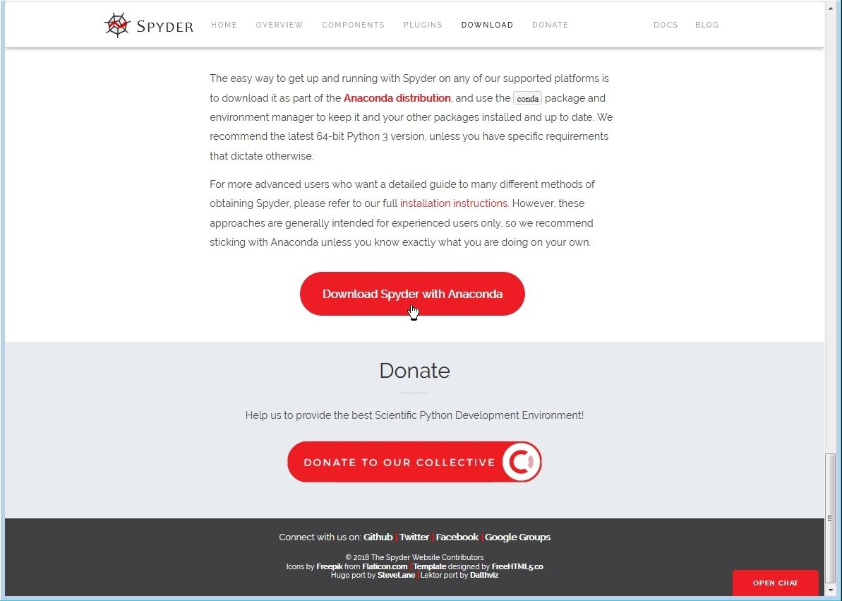

3.3.5

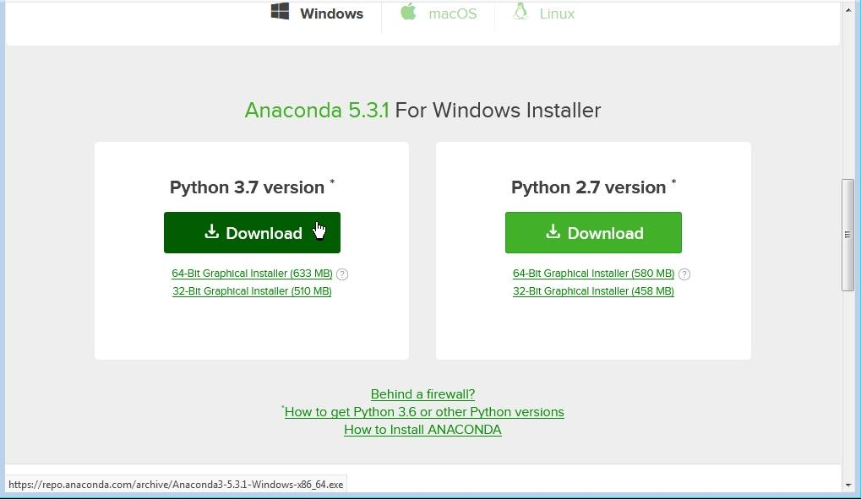

3.4 HTML :

HTML, or Hypertext Markup Language, is the standard language for creating web pages. It uses tags to structure content and define elements like headings, paragraphs, links, images, and forms. HTML documents consist of a hierarchy of elements enclosed in angle brackets, and they're interpreted by web browsers to display content on the internet.

3.5 **CSS :**

CSS, or Cascading Style Sheets, styles HTML elements on web pages, controlling their appearance and layout. It uses selectors to target elements and applies properties with values to define their style. CSS can be inline, embedded, or external. It cascades styles, determining which rules apply to elements. It's essential for web development to create visually appealing and consistent websites

3.6 **JavaScript :**

JavaScript is a programming language used for creating interactive and dynamic content on web pages. It enables developers to add features like form validation, interactive elements, and asynchronous communication.

JavaScript can run both on the client-side, within the user's browser, and on the server-side with platforms like Node.js. It has a vast ecosystem of libraries and frameworks for building modern web applications.

3.7 **MySql :**

MySQL is an open-source relational database management system (RDBMS) that is widely used for building scalable and reliable web applications. Developed by MySQL AB, now owned by Oracle Corporation, MySQL is known for its performance, ease of use, and strong community support.

MySQL has a vibrant community of developers, DBAs, and enthusiasts who contribute to its development, provide support, and share knowledge through forums, blogs, and conferences.

Additionally, MySQL has a rich ecosystem of tools, libraries, and third-party extensions that extend its functionality and integrate it with other technologies.

Django Installation

3.8 **DJANGO INSTALLATION**

**Django HelloWorld Tutorial in Visual Studio Code**

**Prerequisites**

3.8.1 **Install recent version of Python**

a. On Windows, make sure the location of your Python interpreter is included in your PATH environment variable.

b. You can check the location by running path at the command prompt.

c. If the Python interpreter's folder isn't included, open Windows Settings, search for "environment", select Edit environment **variables for your account, then edit the Path variable to include that folder.**

d. Python --version2.

3.8.2 **PIP (Preferred Installer Program)**

` a. To install Django, you must use a package manager like PIP, which is included in Python from version 3.4.

b. To check if your system has PIP installed,

run this command in the command

prompt:pip --version3.

3.8.3 **How To a Create Virtual Environment for Python**

A virtual environment is a self-contained directory tree that contains dependencies required by different projects isolated to existing packages

Why use Virtual Environments?

•The virtual environment creates a directory that contains dependencies required by different projects along with some scripts.

•There are no limitations on the numbers of environments you can create.

•Now let's take another real-world example,

Imagine you have two projects A and B which depend on module C. The problem appears when we need different versions of module C, let's say module A demands v 1.0 and project B demands V 3.0 for some compatibility reason.

•But python won't be able to differentiate between the different versions of a module because both the version will be stored in site package directory with the same name.

How to create Virtual Environment?

Step - 1

•Open command prompt and create a directory to store all your virtual environments, using the command mkdirmkdir environments•Now go inside the directory using the command cd, cd environments

Step - 2

•Now use a module named virtualenv to create isolated virtual environments.

•But first, let's install this module by the following command,

pip install virtualenv

To verify a successful installation run this

virtualenv --version

Create a virtual environment named myenv.

For a Python 3 virtual environment type –

python3 -m venv myenv

This will create a directory myenv along with directories inside it containing a copy of the Python interpreter, the standard library, and various supporting files.

To add modules and packages in our Environment, we need to activate it first

On Windows, run:

myenv\Scripts\activate.bat

To activate environment from power shell use following command

\myenv\Scripts\Activate.ps1

Now your command prompt will be prefixed by the Environment name which is, in this case, myenv. This indicates that our Virtual Environment has been activated.

3.8.4 **Installing Django in The Virtual Environment**

Now, we need to Install Django on our virtual environment.

pip install Django

To check Django version use.

Django-admin --version

Creating A Django Project

create a Django Project:

django-admin startproject hello_world_project

above command creates hello_world_project directory which contains following files

* 1. •manage.py - Command line utility lets you interact with your Django project.
  2. •__init__.py – a blank Python script whose presence indicates to the Python interpreter that the directory is a Python package.
  3. •settings.py – Contains the configuration settings for the Django project.
  4. •urls.py – Contains URL patterns for the Django project.
  5. •wsgi.py – Contains WSGI configuration properties for the Django project.

Now, open VS Code by typing code .

let's apply migrations and test our project. Navigate into the Base directory ( i.e. the outer directory ) and run these commands.

cd hello_world_project

python manage.py migrate

python manage.py runserver

This will start the Django's built-in server now open your preferred browser and navigate to this address http://127.0.0.1:8000/

if everything went well you should see the default Django's welcome page.

Now press ctrl+c in the terminal window, to stop the server.

3.8.5 Creating A Django App

•A Django project is a set of applications and configurations which combined make a full-fledged web application.

•Django apps are the sub-directories inside the Django project.

•The purpose of Django applications is to perform a particular task which in this case is to render 'Hello, World!'.

Make sure you are at the outer directory where manage.py is and run the following.

python manage.py startapp my_app

This will create another directory inside the project called my_app, now the project should look something like this

admin.py - File with admin definitions for the app - such definitions are needed to access model class instances from the Django admin.

1. apps.py - File with configuration parameters for the app.
2. models.py - File with database definitions (i.e., model classes) for the app.
3. tests.py - File with test definitions for the app.
4. views.py - File with view definitions (i.e., controller methods) for the app.
5. migrations - The directory that contains migrations applied to the app’s database definitions (i.e., model classes).

•Now add this app into the Installed apps list in Django's settings so that Django can know about the app.

•Open VS Code and open the settings.py file and scroll to the INSTALLED_APPS section.

•There you should see the list of built-in Django apps.

•Add my_app below the preinstalled apps and save it.

•Note: user-defined apps should always be below the pre-installed apps because Django read the apps in the top to down fashion and our app may rely on the Django's core apps.

Let's create our first view, open views.py file of my_app and add the below lines.

in order to see this view in our browser, we need to map this view in our URL configurations.

•Open the urls.py file of the main project and tell Django explicitly that we need to activate the view for a particular URl.

Now let's test out our app save the files open terminal and run the development server.python manage.py runserver

Now visit http://127.0.0.1:8000/ to see Hello, World!

**Chapter 4**

**METHODOLOGIES**

4.1 **Admin Modules**

4.2 **Dashboard:** Everything that the administrator needs to know is right here, including the overall number of courses. Furthermore, the administrator possesses the power to change passwords and retrieve forgotten passwords.

4.2.1 **User (Student) Modules**

1. Look for courses.
2. Enrol in the course.
3. Get into novels with multimedia elements.
4. Turn in all of your work.

4.2.2 **User (Instructor) Modules**

* 1. Admin can add course.
  2. Admin can remove course.

4.3 **Database Tables**

**Intership Database:**

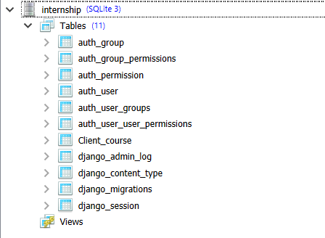

4.3.1 **Contact Us:**

**Authentication Fields:**

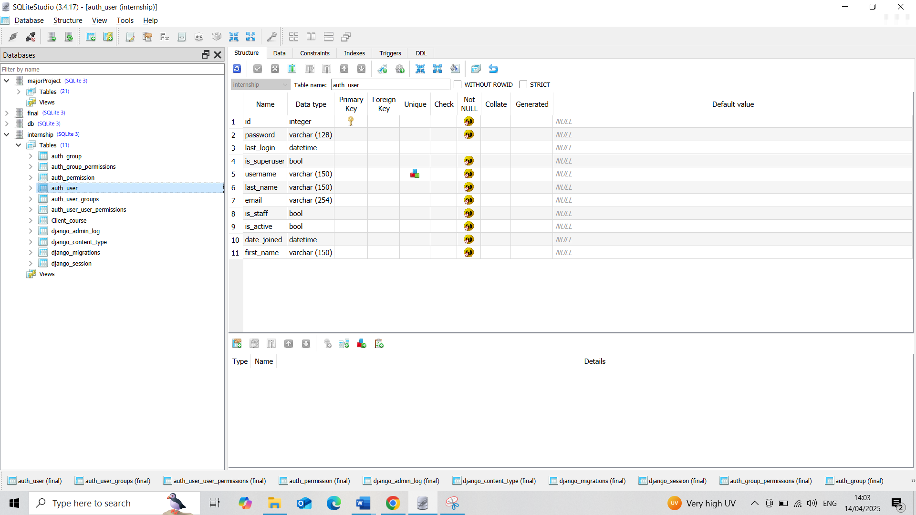

4.3.2 **Contact Data View:**

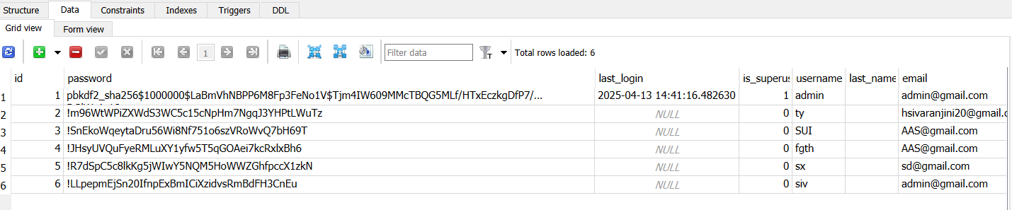

4.3.3 **New Table Creation:**

**Course page:**

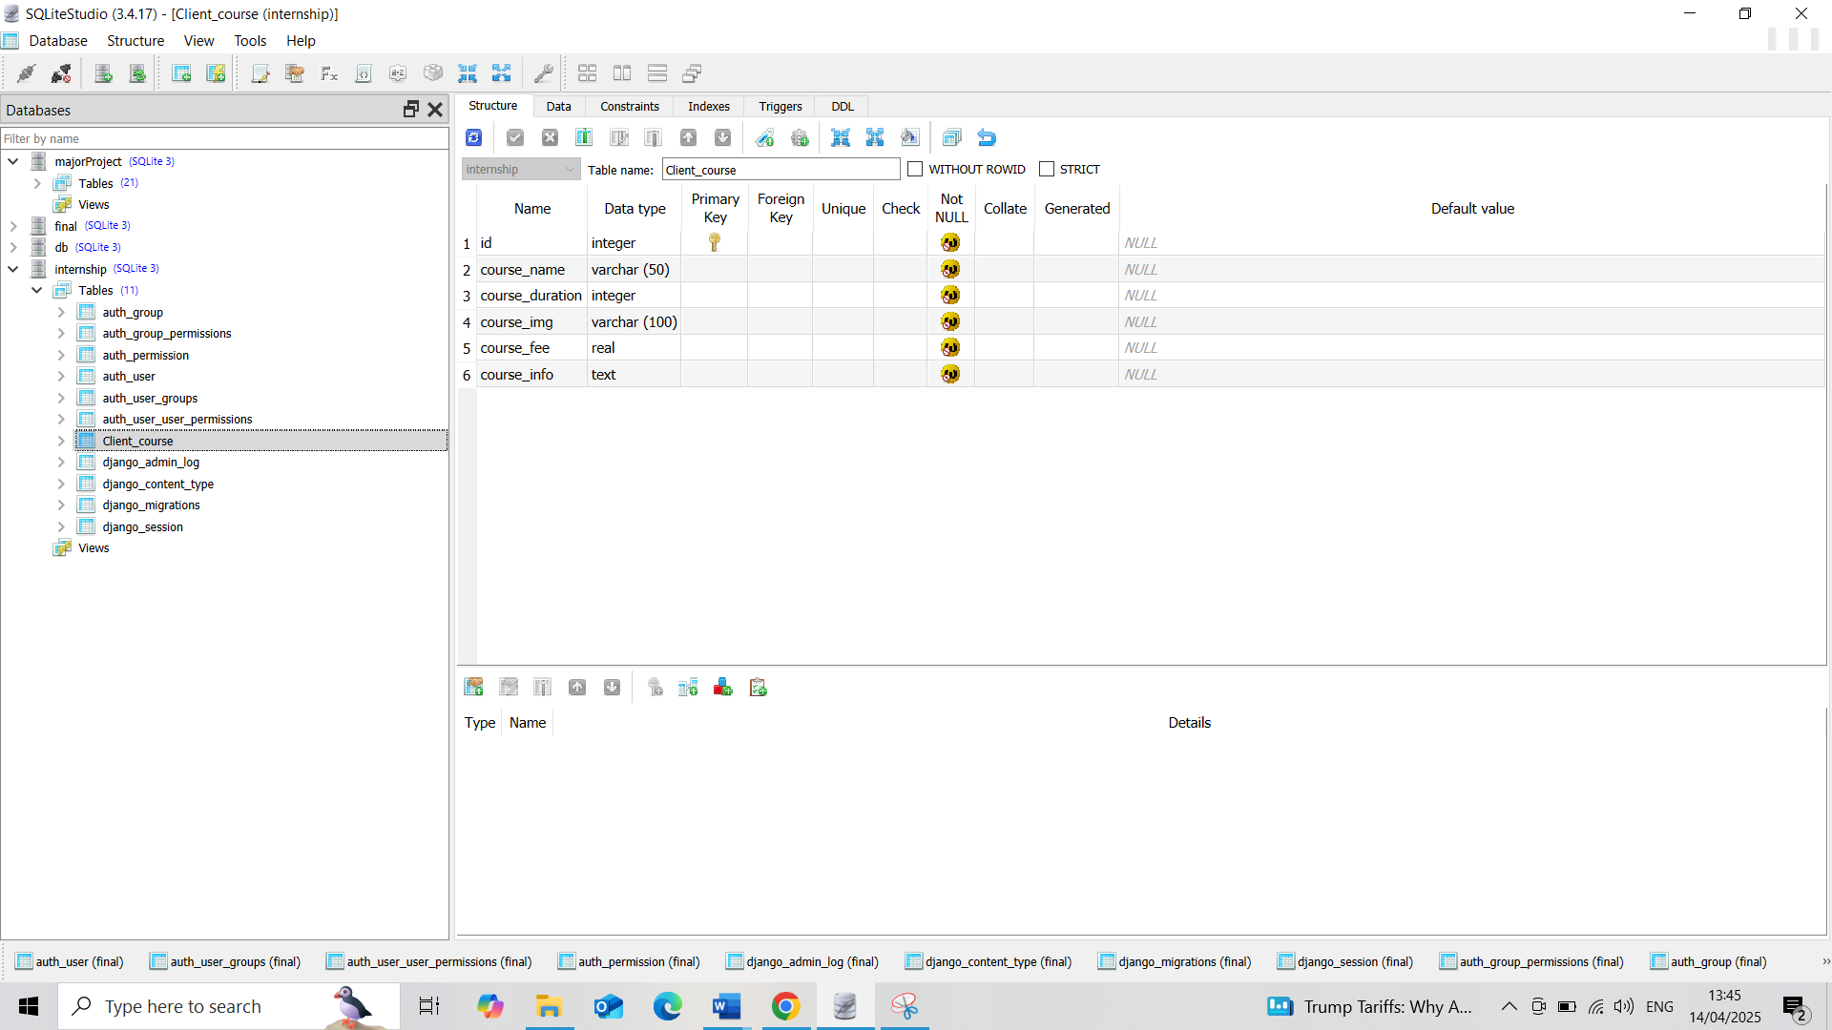

**Course Data View:**

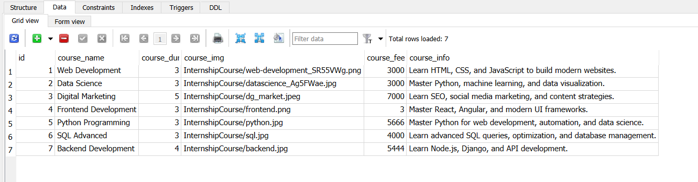

4.4 **SYSTEM DESIGN**

**Use Case Diagram:**

* Use case diagrams show the connection between use cases and actors by combining the two. Among the most crucial considerations is the fact that the main goal is to show how the actor interacts with application scenarios. It is also the goal to portray the system need from the user's perspective. What are called the use cases are the tasks that will be executed within the programme.

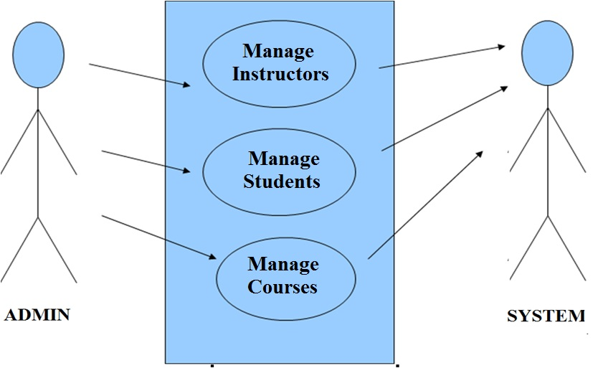4.5 **TESTING METHODS**

4.5.1 **UNIT TESTING**

Unit testing is commonly done as part of the combined coding & unit test process in the software development life cycle. The reality is, though, that development and unit testing are often executed independently. Look over the plan and the procedure. We will physically conduct field testing and meticulously document functional tests.   
Analyse the goals.

• The field's text input must all work correctly. Make sure you pay close attention to the input screen, alerts, and answers. It is necessary to authorise pages from the found connection. Features that should be investigated

• Make sure the submissions are in the right format. Duplicate entries must not be allowed under any circumstances. Additionally, every link must take the visitor directly to the problematic page.

4.5.2 **INTEGRATION TESTING**

Through a process called software integration testing, suitable software components are gradually integrated on a single platform to mimic device-related failures. Checking for error-free communication between the relevant components or programmes is the primary goal of the integration test. For instance, parts of a computer system or, even more specifically, enterprise-level software programmes. Testing Outcomes: Every single one of those test cases was a success. No problems were found.

4.5.3 **ACCEPTANCE TESTING**

The User's Adoption An integral aspect of every project, testing requires heavy input from the people who will be using the final product. On top of that, it ensures the framework can meet the practical obligations. All of the test cases that were discussed before were successful. No problems were found.

4.5.4 **Functional test**

Functional tests are conducted to provide systematic proof that the tested functionalities are available in line with the technical and business requirements, the system documentation, and the user manuals. The following aspects are given top priority during functional testing:   
Valid Input: You must accept the listed types of valid input.   
Valid Input: It's important to dismiss the identified types of invalid input.   
Functions: It is necessary to carry out each and every function which has been identified.   
Application outputs must be exercised according to the defined class.   
Systems and processes: One or both of the interface systems and processes must be activated.   
Organization and execution of functional tests revolve around these pieces, which might be requirements, important functionalities, or specific test cases. Additionally, it is important to think about systematic coverage during testing, specifically as it relates to identifying data fields, business process flows, established procedures, and sequential processes. The functional testing process cannot be completed without first identifying more tests and then determining their actual worth.

4.5.5 **System Test**

System testing ensures that all parts of the connected software system meet the standards. It checks a configuration to make sure the results have been established and predictable. System testing includes examples like the configuration-oriented integration of systems test. With an emphasis on pre-driven process links and integration milestones, system testing is built around process descriptions and flows.

4.5.6 **White Box Testing**

When conducting white box testing, it is assumed that the tester knows the product's intended use case and has some familiarity with its internal workings, architecture, and language. Why? Because of this. You can use it to test sites that are inaccessible from a black box level.

4.5.7 **Black Box Testing**

The phrase "black box testing" describes the method of testing software when the tester is not aware of the inner workings, architecture, or user interface of the tested module. The specifications or requirements documents serve as the final source documents from which the bulk of the 26 test types—including black box tests—must be derived. Additionally, these documents must be used to construct black box testing. One way to do this kind of testing is to pretend the software under scrutiny is a mysterious black box.Being able to "see" inside it is not feasible. As the testing progresses, the program is ignored in favor of providing inputs and responding to outputs.

Chapter 5

5.1 **RESULTS** **/** **OUTPUTS**

5.1.1 **Elearn.html(Home)**

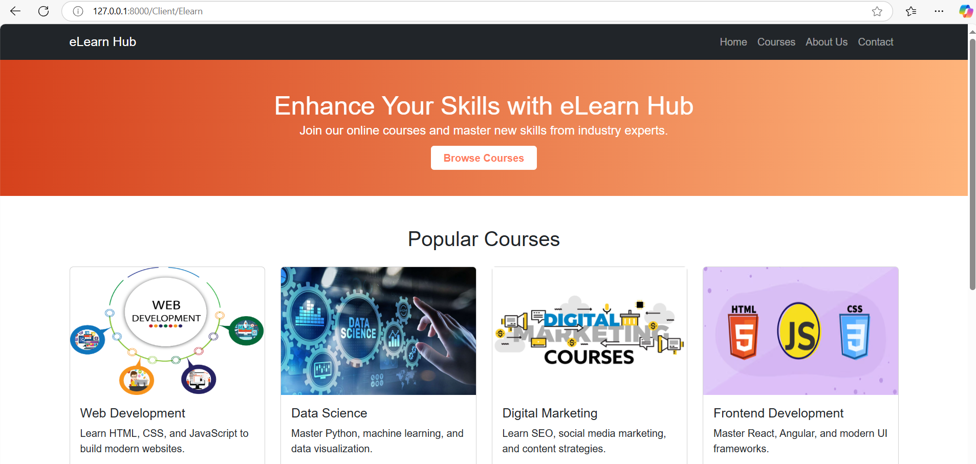

5.1.2 **Course.html(DB connected)**

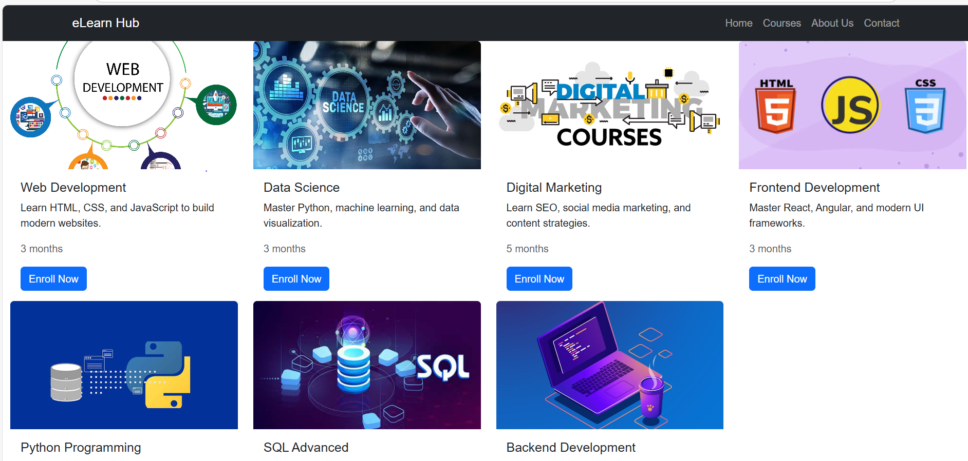

5.1.3 **Sign up.html/login.html**

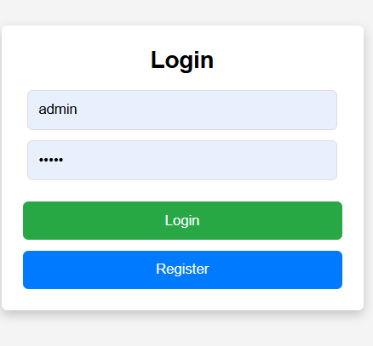

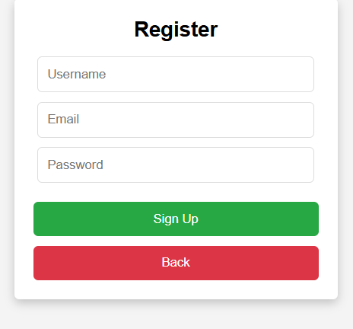

5.1.4 About.html

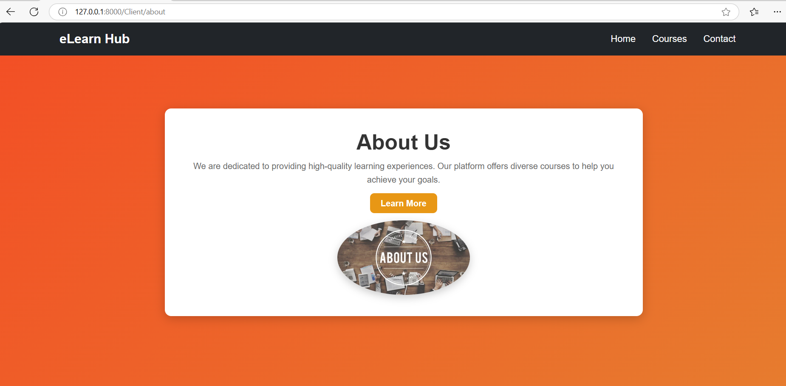

5.1.5 Contact.html(DB Connected)

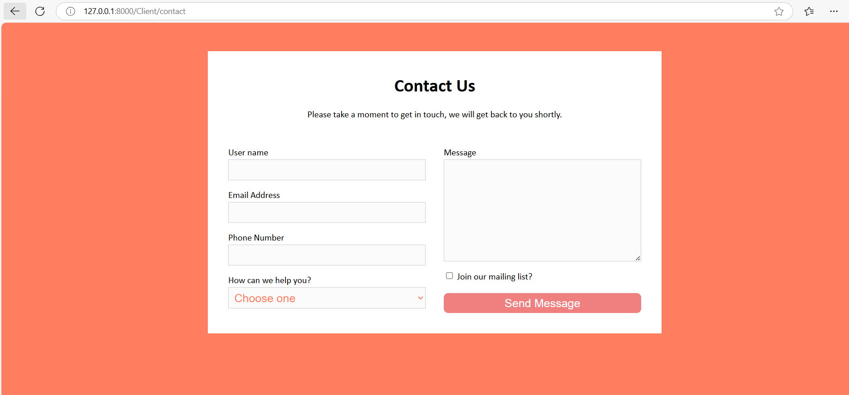

**CONCLUSION**

The process of creating the e-learning system is evaluated at every turn. The steps involved in this process include requirements analysis, design, development, and implementation. At its core, development begins with the supply of GBIM, storyboards, and guided flow diagrams tailored to the characteristics of vocational education. The results of the validation showed that the degree of feasibility for material representatives was 80.71% and for media representatives it was 79.18%. It follows that learning management systems (LMS) offer a promising alternative to traditional classroom settings for meeting the media and material needs of vocational education. The LMS consistently receives positive and consistent feedback from students in both small and limited group testing. This situation is generating a great deal of enthusiasm and attention among the students.

**REFERENCES**

The following study was published in February 2019 by R. E. Islami, I. J. Sari, S. Sjaifuddin, M. Nurtanto, M. Ramli, and A. Siregar: "An Assessment of Pre-service Biology Teachers on Student Worksheets Based on Scientific Literacy." Page 012068 of volume 1155 of the Journal of Physical Conference Series contains the published results of this investigation.   
"An evolving Learning Management System for new educational environments using 2.0 tools." was the title of a paper published in March 2014 by M. Á. Conde, F. J. García-Peñalvo, M. J. RodríguezConde, M. Alier, M. J. Casany, and J. Piguillem. The journal Interact. Learn. Environ. published this article in volume 22, issue 2, pages 188-204.   
"Development of Learning Management System (LMS) As An Effort In Increasing Learning Effectiveness And Learning Activities Of Students In Sriwijaya University." A September 2014 essay by I. Sriyanti and J. Jauhari. Volume 1, pages 196-201 of the Eurasia Proceedings of the Education and Science Society first published this article.   
Their 2012 work was titled "Using the Facebook group as a learning management system: An exploratory study." Q. Wang, H. L. Woo, C. L. Quek, Y. Yang, and M. Liu were the authors. Volume 43, issue 3, pages 428–438 of the British Journal of Educational Technology is where this piece was published.   
The following paper was published in October 2019 by M. Nurtanto, D. Widjanarko, H. Sofyan, Rabiman, and M. B. Triyono: "Learning by Creating: Transforming Automotive Electrical Textual Material into Visual Animation as a Creative Learning Product." This piece appeared in the most recent issue of the International Journal of Scientific and Technological Research.   
Writing for Learning Management Systems, T. Andersson presents a case study on an LMS installation and the effects that teachers saw. The year 2019.   
Article "Acceptance of learning management system: The case of secondary school teachers" was published by A. Stockless in May 2018 in the journal Educ. Inf. Technol., volume 23, number 3, pages 1101-1121.   
B. Beatty and C. Ulasewicz wrote an essay in August 2006 called "Faculty Perspectives on Moving from Blackboard to the Moodle Learning Management System." Volume 50, issue 4, pages 36–45 of TechTrends is where this paper was published.   
Pages 1–20 of the 2019 journal Stud.-Centered Virtual Learn. Environment of High Education featured the article "Indicators for Cooperative, Online-Based Learning and Their Role in Quality Management of Online Learning," written by E. Ammenwerth, W. O. Hackl, A. Hoerbst, and M. Felderer.   
"Mining LMS data to develop an early warning system for educators: A proof of concept" was published in February 2010 by L. P. Macfadyen and S. Dawson in the journal Computers in Education, volume 54, number 2, pages 588-599.

**USER MANUAL**

Step 1: Opening the Anaconda application and launching the PyCharm community or visual studio are the first steps.   
Step 2: Launch Anaconda and install the packages for the Django Python library.   
Step 3: Enter the project's localhost address into the command prompt and run the python run server command.   
Step 4: In Chrome's address bar, copy the localhost address and paste it.   
Step 5: is to display the project homepage by running the project at the localhost address.   
Step6: Enter the User's Password and Login.   
Step 7: the user uses the data on to view Course Details.

Step 8: Admin add Course Details and view Student enquiry details

Step 9: Logout the Website